**Module 3 Assignment**

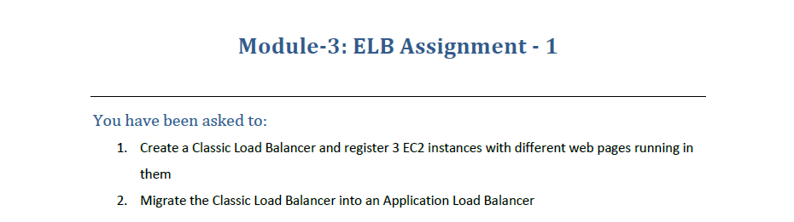

1. Create 3 Instances

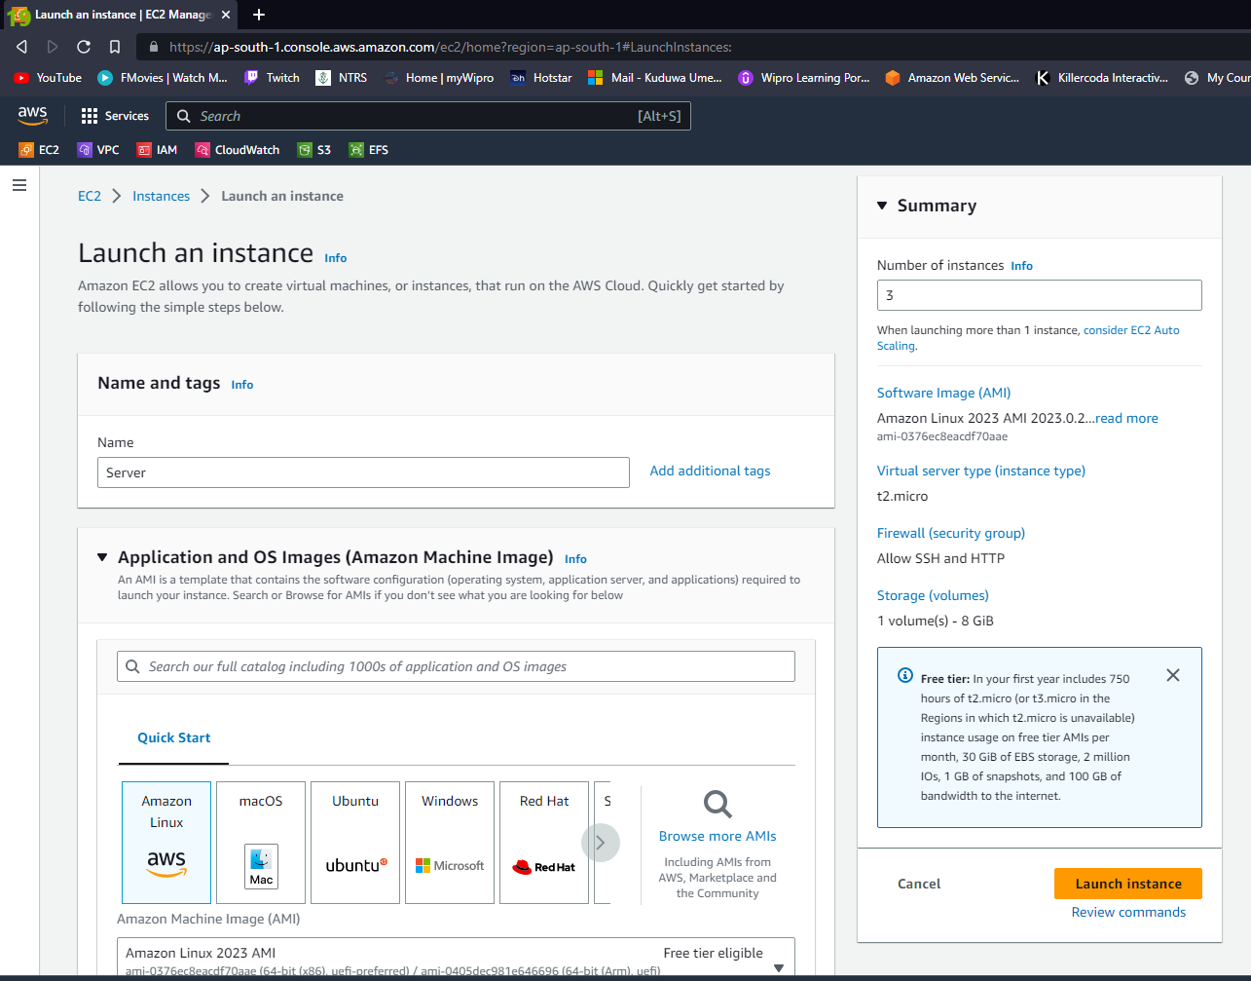

1. Use the below Userdata Script to Install httpd service in all the 3 Instances.

* #!/bin/bash
* yum update -y
* yum install -y httpd
* systemctl start httpd
* systemctl enable httpd
* echo "<h1>Hello World from $(hostname -f)</h1>" > /var/www/html/index.html

1. Create a Classic LB and Attach all the 3 Instances to the LB.

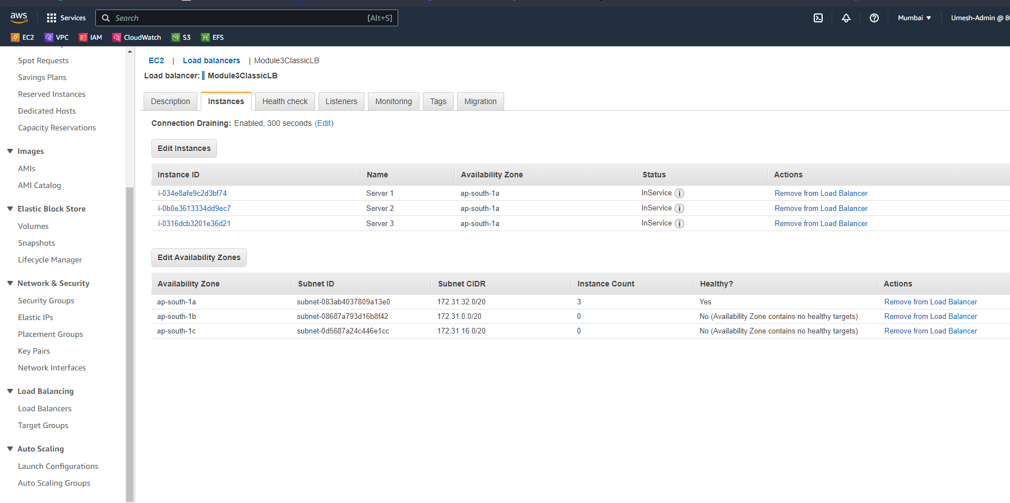

1. Copy the DNS Name of the Classic LB and Search, if you refresh that page you will observe it’s load-balancing to all the 3 Instances Attached.

Server 1 :

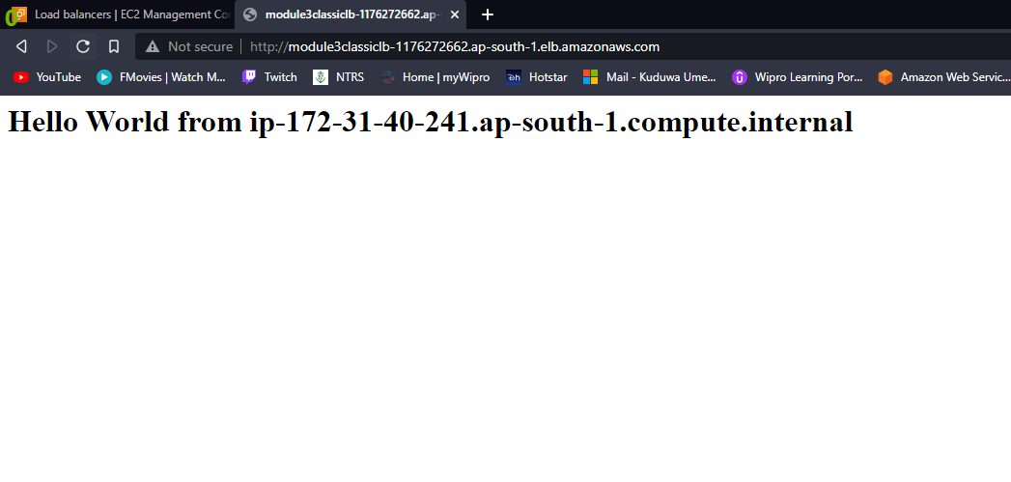

Server 3 :

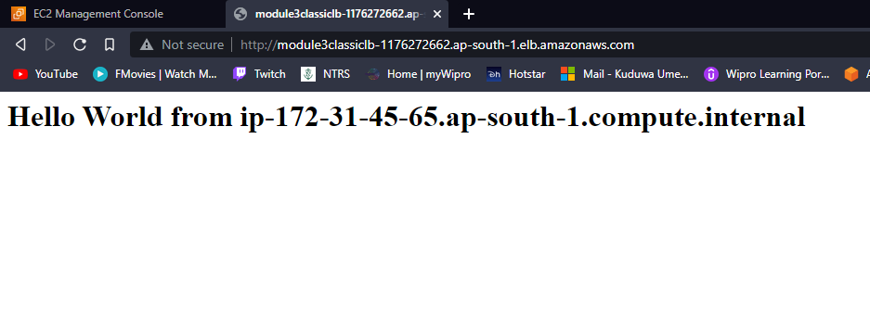

Server 2 :

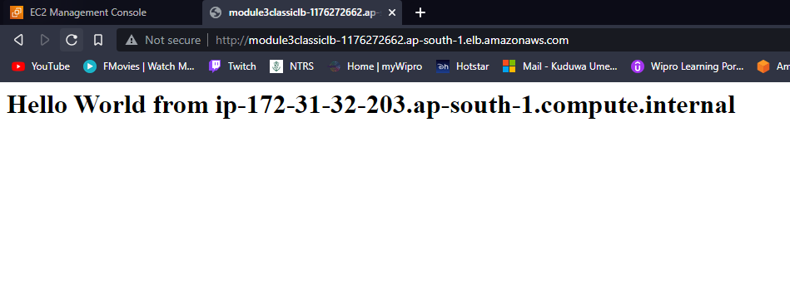

1. To Migrate the CLB to ALB :
   1. Go to the CLB and Choose Migration Tab :

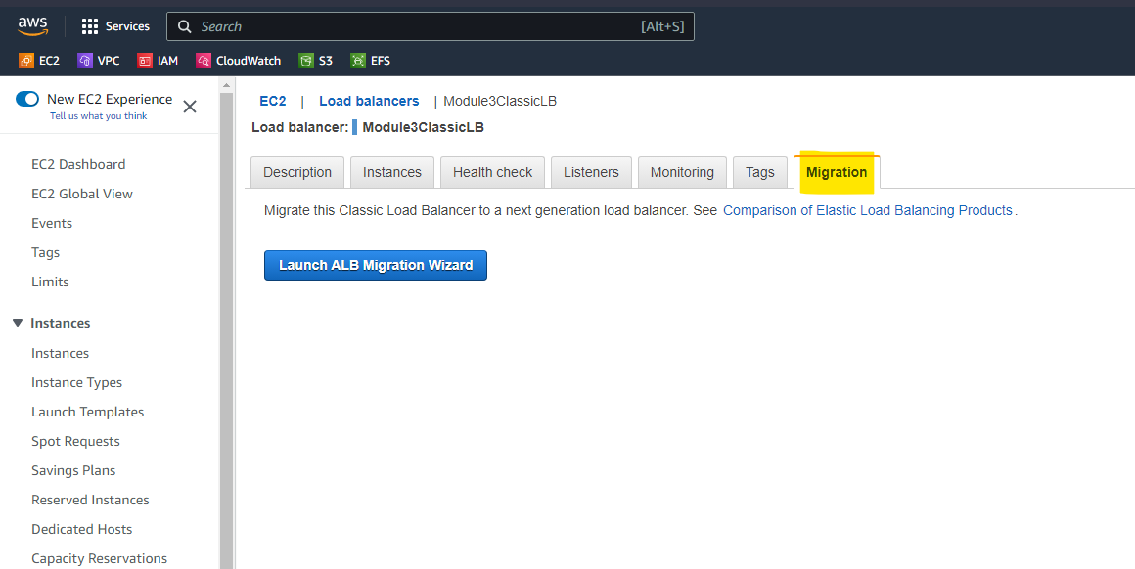

* 1. Once Migration is Completed a New ALB is Created, search through the DNS Name of the newly created ALB, you will be able to browse all the 3 servers via Application Load Balancer.

